Final Report

# Introduction

# Results

# Descriptive Statistics

### Income and Education

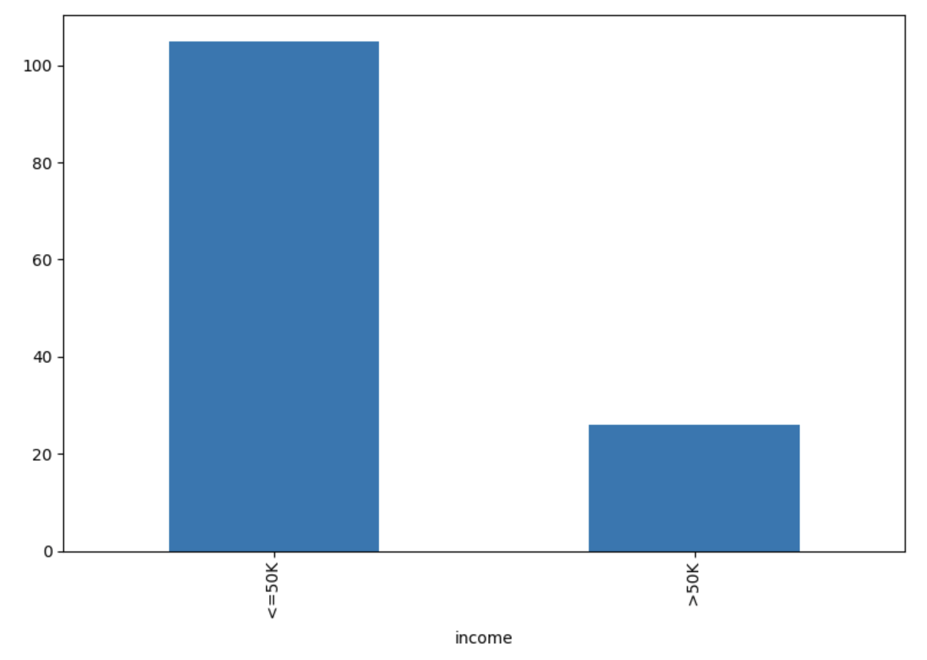

*Table: Income Count (Descending Order)*

| <=50K | 24720 |
| --- | --- |
| > 50K | 7841 |

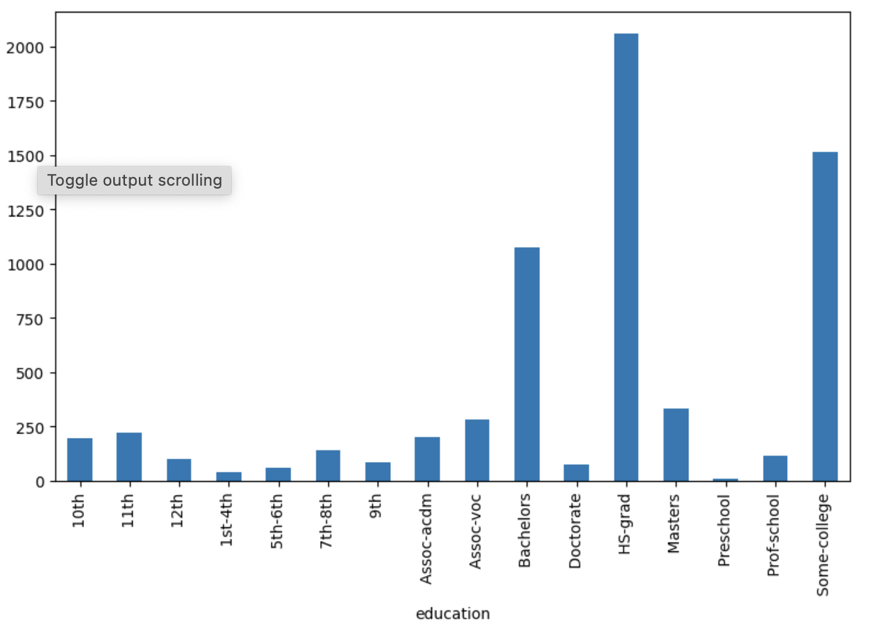

*Table: Education Count (Descending Order)*

| HS-grad  Some-college  Bachelors  Masters  Assoc-voc  11th  Assoc-acdm  10th  7th-8th  Prof-school  9th  12th  Doctorate  5th-6th  1st-4th  Preschool | 10501  7291  5355  1723  1382  1175  1067  933  646  576  514  413  333  168  51 |
| --- | --- |

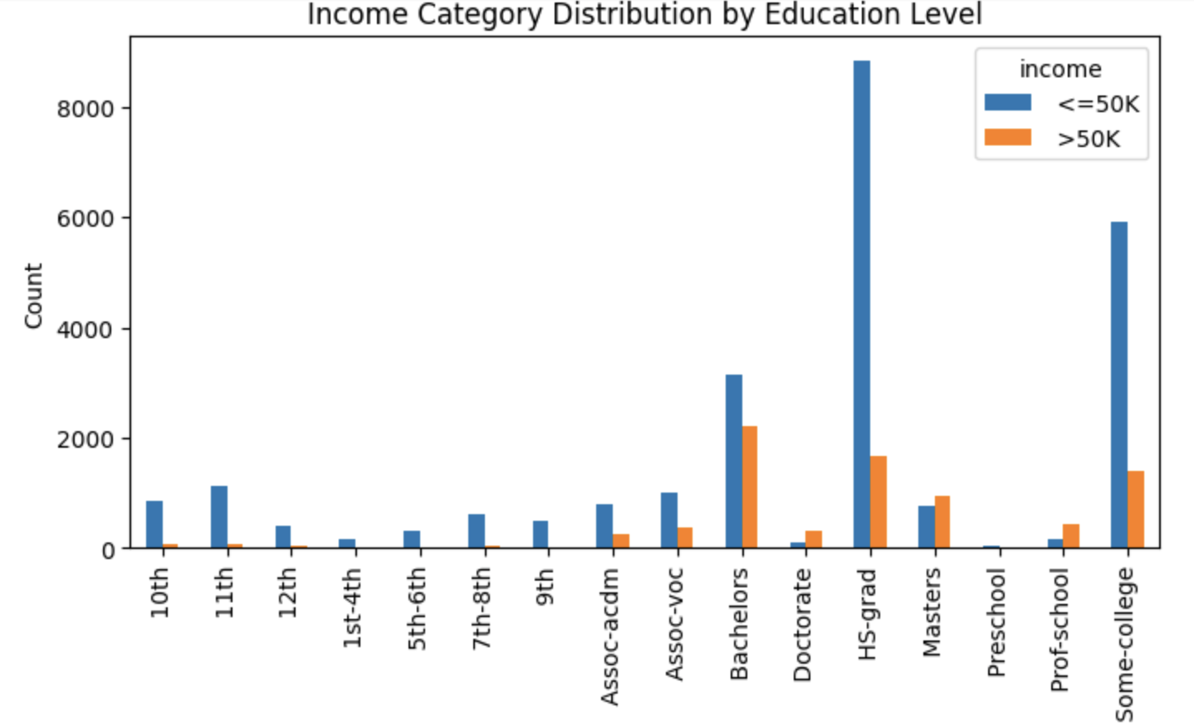

### Hour Per Week

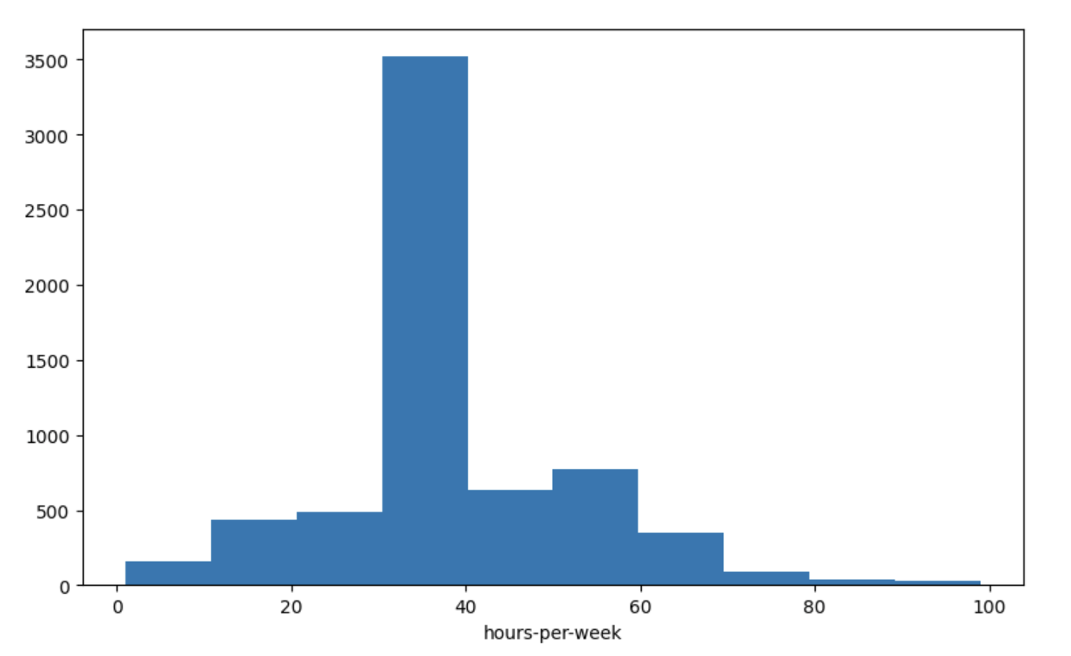

*Table: Hours-Per-Week (Descending Order)*

| 40 | 15217 |
| --- | --- |
| 50 | 2819 |
| 45 | 1824 |
| 60 | 1475 |
| 35 | 1297 |
| … | … |
| 82 | 1 |
| 92 | 1 |
| 87 | 1 |
| 74 | 1 |
| 94 | 1 |

Mean hours-per-week = 40.44

Standard Deviation hours-per-week = 12.35